TEACHING WITH LEGOs
GETTING STARTED

Course: CIS 102Q – Problem Solving Using LEGO Robotics
Problem Solving Using LEGO Robotics is a 3-credit hour course offered at Pace University of Pleasantville, New York and New York City. It is an introductory robot-based design course that not only extends efforts in the field of computing and robotics but also serves the community by establishing robotics clubs in middle schools or high schools located in New York City and Westchester. The class uses a project-based learning environment, and teaches robotics, computer programming concepts and problem solving skills to Pace students of all majors. Students work in teams toward the common goal of developing logical and creative solutions to problems using LEGO robotics technology known as Mindstorms. They perform service learning by going out to area middle schools and high schools, teaching students and their teachers and coaches about the LEGO robotics technology, exciting the students with a fun yet valuable experience in science and technology.

Curricular Options:
- Advanced Placement CIS 102Q
High school students receive college credit (3 credits) for completing this 14 week course. The course maybe administered at the high school by high school faculty or Pace faculty. If administered at the high school, the high school faculty will be provided with all the course ancillaries and rubrics as well as obtain one-on-one training of how to teach the course.
- Integration of a Five Week Robotic Module
This multimedia curriculum provides teachers with an engaging program to teach STEM concepts utilizing the LEGO Mindstorms NXT Robots. Students will learn how to program basic robot behaviors using motors and rotation, sound, light, touch and ultrasonic sensors. Five in-depth projects cover stem concepts and the program concludes with a robot competition.
- Establish or Support an After school LEGO Club
Pace University students will provide training for those teachers who want to become coaches and create a LEGO club at their schools. If LEGO clubs are participating in the FIRST LEGO League Competition or the FIRST TECH Challenge, Pace University students will assist the club in preparing for the competition.

LEGO Support Network
An online community which supports teachers who are integrating robotics in their classrooms. Participating schools are:
- Alexander Hamilton
- Alice E. Grady Middle School
- Carmel High School
- Pleasantville Middle School
- Woodlands Middle School and High School
Partnering With Pace
Dr. Mosley, Robotics Program Coordinator, will assess your math or technology curriculum and suggest how it can be enriched by utilizing LEGO robotics. Pace University is committed to supporting your school as it embraces robotics.

What is FIRST?
FIRST (For Inspiration and Recognition of Science and Technology) was founded in 1989 to inspire young people's interest and participation in science and technology. Based in Manchester, NH, the 501 (c) (3) not-for-profit public charity designs accessible, innovative programs that motivate young people to pursue education and career opportunities in science, technology, engineering, and math, while building self-confidence, knowledge, and life skills.
Site: www.usfirst.org

The LEGO Competitions
FIRST Robot Competition (high school)
FIRST Tech Challenge (high school)
FIRST LEGO League (ages 9-14)
Junior FIRST LEGO League (ages 6-9)
FIRST Place (all ages)

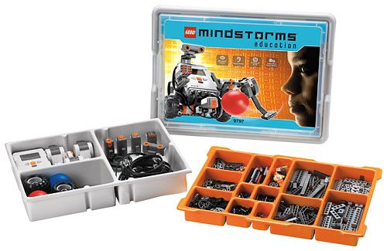Purchasing LEGOs
LEGO MINDSTORMS Education NXT
Base Set - $260.00
Site: www.legoeducation.com

Contact Information
Dr. Pauline Mosley
Associate Professor
Pleasantville, New York
Goldstein Academic Center RM 322
Phone: (914) 773-3986
Cell: (914) 447-4395
Fax: (914) 773-3533
Email: pmosley@pace.edu



Pace University
The Ivan G. Seidenberg School of Computer Science and Information Systems

1 Pace Plaza
New York, NY 10038
861 Bedford Road
Pleasantville, NY 10570
1 Martine Avenue
White Plains, NY 10606

