Usability Test of
www.volunteer-center.org/leadershipwestchester

___________________________________________

May 9, 2006

Prepared by Team LCM (Lanbing Bowman, Carolyn Kucsera, Mini Mathew)
________________________________________________________________________

I. Approach

1. Purpose

The primary purpose of the test was to assess the usability of the Leadership Westchester website for target users mainly in Westchester and Putman counties. The test also was to verify the robustness of the site and to identify problem spots in terms of details and general designs in order to make significant improvements of the final site.

2. Method

Each team members interviewed 10 test participants. A total of 30 test participants were interviewed. Test participants were asked to fill in a questionnaire without bias.

II. Test Participant Profiles

- In General:

The tests were carried out with test participants who fulfilled the following requirements:

- The number of men and women were relatively balanced
- The age covered from 20 to 60
- Internet experiences were between 3 years and experts

Participant | Gender | Age | Internet experience | Knows Volunteer Center?
1 | Male | 20-40 | More than 7 years | No
2 | Female | 20-40 | More than 7 years | No
3 | Female | Over 60 | 1-3 years | No
4 | Male | 40-60 | 3-7 years | Yes
5 | Female | Over 60 | Experts | No
6 | Female | 20-40 | More than 7 years | No
7 | Male | 40-60 | 3-7 years | Yes
8 | Male | 40-60 | 3-7 years | Don’t know
9 | Male | 40-60 | More than 7 years | No
10 | Male | 40-60 | More than 7 years | Yes
11 | Female | 20-40 | More than 7 years | No
12 | Female | 40-60 | Experts | Yes
13 | Female | 20-40 | 3-7 years | No
14 | Female | 20-40 | More than 7 years | No
15 | Female | Over 60 | 1-3 years | No
16 | Male | 20-40 | More than 7 years | Don’t know
17 | Female | 20-40 | 3-7 years | Yes
18 | Female | 40-60 | More than 7 years | Yes
19 | Female | Under 20 | Experts | No
20 | Female | 20-40 | More than 7 years | Yes
21 | Male | 40 | More than 7 years | Yes
22 | Male | 40 | Experts | Yes
23 | Female | 20-40 | More than 7 years | Yes
24 | Female | 20-40 | 1-3 years | No
25 | Female | 40-60 | 1-3 years | No
26 | Female | 20-40 | Expert | No
27 | Male | 20-40 | Expert | No
28 | Male | 20-40 | Expert | No
29 | Male | 40-60 | 1-3 years | Yes
30 | Female | 20-40 | More than 7 years | No

- Detailed Analysis About Test Participants’ Profile
_____________________________________________________________________
Gender: | Male | Female |  | Comments
n=30 | 12 | 18 |  | Genders are relatively balanced
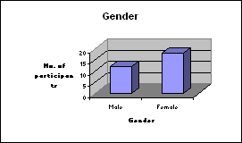

Age: | Under 20 | 20-40 | 40-60 | Over 60
n=30 | 1 | 15 | 11 | 3
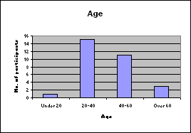 |  |  |  |  | Comments
 |  |  |  |  | Most participants are between
 |  |  |  |  | 20 and 60 years old
Internet experience |  | 1-3 years | 3-7 years | More than 7 years | Experts
n=30 |  | 5 | 4 | 13 | 7
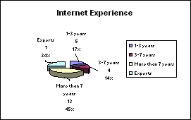 |  |  |  |  | Comments
 |  |  |  |  | Majority of participants are
 |  |  |  |  | somewhat computer experienced
III. Findings – www.volunteer-center.org/leadershipwestchester

- Detailed Analysis of three general questions:
Do you know about the Volunteer Center?
n=30 |  |  |  |  |  |  |  |  |  |  | Yes |  |  | No |  |  | Don't Know
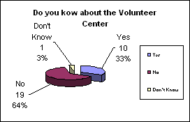 |  |  |  |  |  |  |  |  |  |  | 10 |  |  | 19 |  |  | 1
 |  |  |  |  |  |  |  |  |  |  | Comments:
 |  |  |  |  |  |  |  |  |  |  | Over 50% of test participants
 |  |  |  |  |  |  |  |  |  |  | do not know about
 |  |  |  |  |  |  |  |  |  |  | the Volunteer Center
Will you visit this web site again in the future?
n=30 |  |  |  |  |  |  |  |  |  |  | Yes |  |  | No |  |  | Don't Know
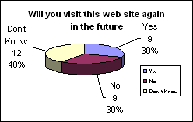 |  |  |  |  |  |  |  |  |  |  | 9 |  |  | 9 |  |  | 12
 |  |  |  |  |  |  |  |  |  |  | Comments:
 |  |  |  |  |  |  |  |  |  |  | 30% of the people will visit
 |  |  |  |  |  |  |  |  |  |  | the site in the future
 |  |  |  |  |  |  |  |  |  |  | 30% of the people will not
 |  |  |  |  |  |  |  |  |  |  | visit the site in the future
 |  |  |  |  |  |  |  |  |  |  | 40% of the people are not sure
 |  |  |  |  |  |  |  |  |  |  | whether they will visit the site
 |  |  |  |  |  |  |  |  |  |  | or not
Were you able to locate "contact information" immediately?
n=30 |  |  |  |  |  |  |  |  |  |  | Yes |  |  | No |  |  | Don't Know
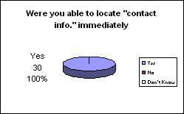 |  |  |  |  |  |  |  |  |  |  | 30 |  |  | 0 |  |  | 0
 |  |  |  |  |  |  |  |  |  |  | Comments
 |  |  |  |  |  |  |  |  |  |  | 100% of the participants were
 |  |  |  |  |  |  |  |  |  |  | able to locate "contact info."
 |  |  |  |  |  |  |  |  |  |  | immediately
- Detailed Analysis of questions about the web site including text, navigation and links, graphics, and general design:
Text
 | 68% of test participants rated "good" or "excellent"
 | in terms of text colors and sizes
n=30 | Poor | Acceptable |  |  |  |  |  | Good |  | Excellent
 | 0 | 2 |  |  |  |  |  | 20 |  | 8
 | 0 | 4 |  |  |  |  |  | 10 |  | 16
 | 0 | 6 |  |  |  |  |  | 30 |  | 24
 | 0% | 8% |  |  |  |  |  | 38% |  | 30%
 | 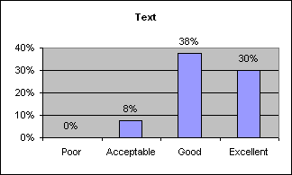
Navigation and Links
 | 61% of test participants rated "good" or "excellent"
 | in terms of navigation efficiency and links visibility
n=30 | Poor | Acceptable |  |  |  |  |  | Good |  | Excellent
 | 0 | 5 |  |  |  |  |  | 11 |  | 14
 | 0 | 6 |  |  |  |  |  | 10 |  | 14
 | 0 | 11 |  |  |  |  |  | 21 |  | 28
 | 0% | 14% |  |  |  |  |  | 26% |  | 35%
 | 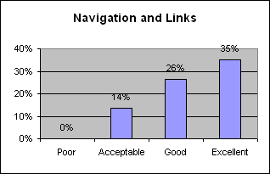
Graphics
 | 69% of test participants rated "good" or "excellent"
 | in terms of designs of graphics
n=30 | Poor | Acceptable |  |  |  |  |  | Good |  | Excellent
 | 0 | 2 |  |  |  |  |  | 16 |  | 12
 | 0 | 3 |  |  |  |  |  | 15 |  | 12
 | 0 | 5 |  |  |  |  |  | 31 |  | 24
 | 0% | 6% |  |  |  |  |  | 39% |  | 30%
 | 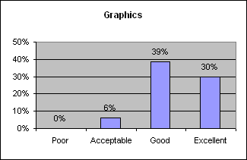
General Design
 | 71% of test participants rated "good" or "excellent"
 | in terms of general design including download speed and the theme and uniformity of every web page in the site.
n=30 | Poor | Acceptable |  |  |  |  |  | Good |  | Excellent
 | 0 | 0 |  |  |  |  |  | 14 |  | 16
 | 1 | 2 |  |  |  |  |  | 10 |  | 17
 | 1 | 2 |  |  |  |  |  | 24 |  | 33
 | 1% | 3% |  |  |  |  |  | 30% |  | 41%
 | 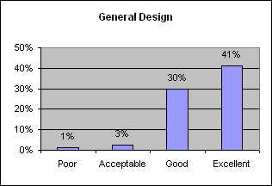

IV. Conclusion:

In observing the detailed analysis of the three general questions, there were over 50% of test participants who did not know about the Volunteer Center. Therefore, we concluded that the original web site is not well known in the community. 30% of the people will visit the site in the future; 30% of the people will not visit the site in the future; 40% are not sure whether they will visit the site or not. 100% of the test participants were able to locate “contact information” immediately. Therefore we concluded that it is a site with a lot of potential due to its efficiency in leading users to useful information. 40% of the unsure participants are potential target users.

In observing detailed analysis about the web site including text, navigation and links, graphics, and general design, there were 68% of test participants who rated the text colors and sizes “good” or “excellent”; 61% rated “good” or “excellent” the navigation efficiency and links visibility; 69% rated the graphic designs “good” or “excellent”; 71% rated “good” or “excellent” the general design including download speed and the theme and uniformity of every web page on the site.

In conclusion, among all questions regarding the site, the majority of the scores were between “good” and “excellent”. Therefore, the feedback from the 30 test participants about the web site is mainly positive.

