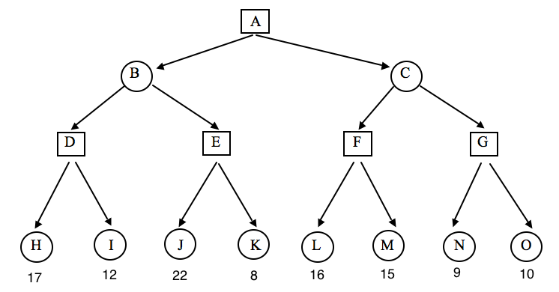

D: 17 B: <= 17 E: 22 B: 17
A: >= 17 K pruned F:16 C: <= 16 pruned: G, N, O

