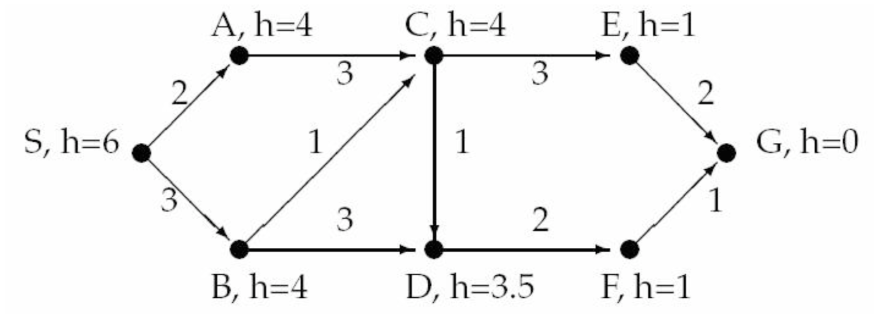

A*
Expanded nodes Open nodes (fringe)
S(0+6)
S(0+6) A(2+4), B(3+4)
A(2+4) CA(5+4), B(3+4)
B(3+4) CA(5+4), CB(4+4), DB(6+3.5)
CB(4+4) CA(5+4), DB(6+3.5), DC(5+3.5), E(7+1)
E(7+1) CA(5+4), DB(6+3.5), DC(5+3.5), GE(9+0)
DC(5+3.5) CA(5+4), DB(6+3.5), GE(9+0), F(7+1)
F(7+1) CA(5+4), DB(6+3.5), GE(9+0), GF(8+0)
GF(8+0) CA(5+4), DB(6+3.5), GE(9+0)
GF-F-DC-CB-B-S

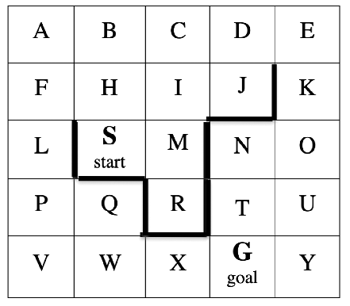

Best-first
Expanded fringe

A* - Manhattan Heuristic
Expanded fringe

