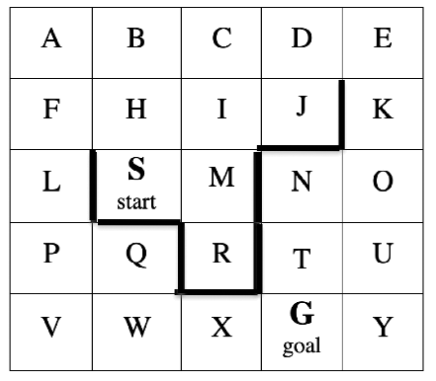
Hill-climbing – Manhattan heuristic
Expanded nodes Open nodes
S(4)
S H(5), M(3)
M I(4), R(2)
R no solution

A* - Manhattan Heuristic
Expanded nodes Open
S(0+4)
S H(1+5), M(1+3)
M H(1+5), I(2+4), R(2+2)
R H(1+5), I(2+4)
H I(2+4), B(2+6), F(2+6)
I B(2+6), F(2+6), C(3+5), J(3+3)
J B(2+6), F(2+6), C(3+5), D(4+4)
B F(2+6), C(3+5), D(4+4), A(3+7)
C F(2+6), D(4+4), A(3+7)
D F(2+6), A(3+7), E(5+5)
F A(3+7), E(5+5), L(3+5)
L A(3+7), E(5+5), P(4+4)
P A(3+7), E(5+5), Q(5+3), V(5+3)
Q A(3+7), E(5+5), V(5+3), WfromQ(6+2)
V A(3+7), E(5+5), WfromQ(6+2), WfromV(6+2)
W A(3+7), E(5+5), X(7+1)
X A(3+7), E(5+5), G(8+0)
G solution: G-X-W-Q-P-L-F-H-S

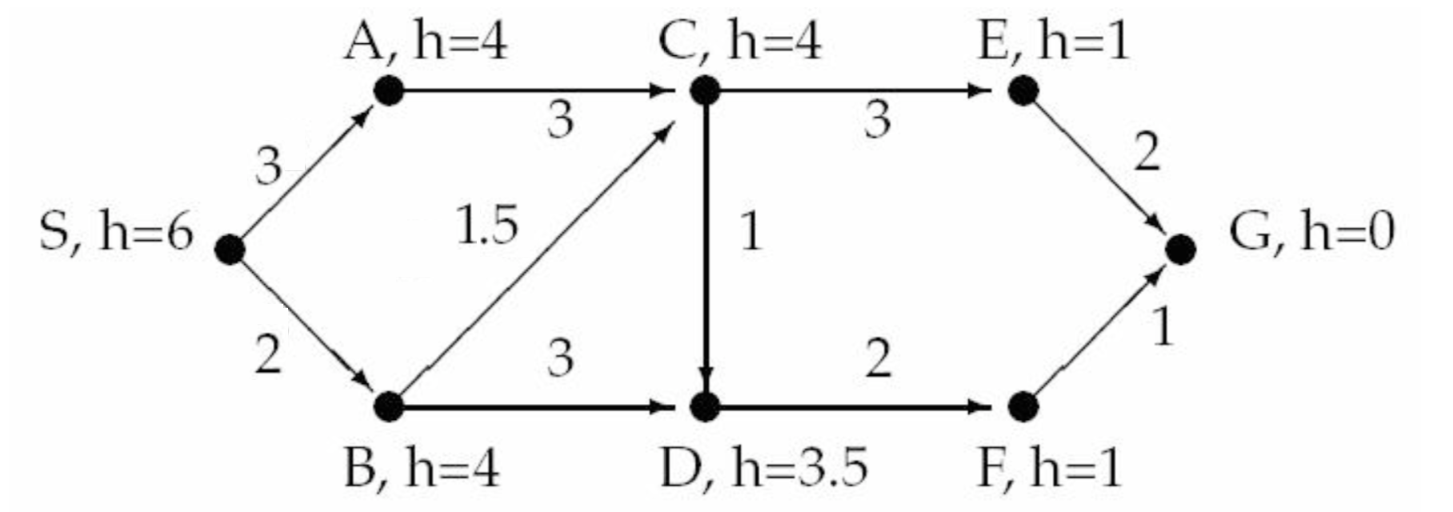

A*
Expanded Nodes Open
S(0+6)
S A(3+4), B(2+4)
B A(3+4), CfromB(3.5+4), DfromB(5+3.5)
A CfromB(3.5+4), DfromB(5+3.5), CfromA(6+4)
CfromB DfromB (5+3.5), CfromA(6+4), DfromC(4.5+3.5), E(6.5+1)
E DfromB (5+3.5), CfromA(6+4), DfromC(4.5+3.5), G(8.5+0)
DfromC DfromB (5+3.5), CfromA(6+4), G(8.5+0), F(6.5+1)
F DfromB (5+3.5), CfromA(6+4), G(8.5+0), GfromF(7.5+0)
GfromF solution: G-F-D-C-B-S

Hill-Climbing
S A C E G

