ATM Web Interface

Last Update: 9 May 2004

By Team1

Ardian Haliti
Arvinder Singh
Andrew Newsome
Lisa Lau

IS660G

Table of Contents
Project Objectives 1
System Objectives 1
Operations Requirements Summary 1
Requirements 1
Benefit Summary 3
Security 3
Web Transactions 3
Web Security 4
Not In Scope 4
Change Control Methodology 5
Risk Management Plan 5
Project Control Scenario 5
ER-Diagram 6
Use Case Diagram 7
Data Flow Diagram – Top Process 8
Data Flow Diagram – Detail 9
References 10

ATM Web Interface
9 May 2004

Project Objectives

The primary objective of this project is to design the ATM Web Interface, which provides the features of cash withdraw, deposit and account summary. The system will provide the clients to server concept using the Web Service, JAVA, JSP and HTML.

It will add great value for the banking business to adopt the Web services. It can indeed offer new value-added services to their customers when they’re capable of exchanging information and processing between systems. Web services will allow for backend-to backend connectivity between companies and it can extend the possibilities to streamlined operations and information exchange. More and more people have access to Internet now and the power of Web services, in addition to their great interoperability and extensibility using XML, is that they can then be combined in a loosely coupled way in order to achieve complex operations. Programs providing simple services can interact with each other in order to deliver sophisticated added-value services. Think about that you can access the bank information thru Internet, linking all your accounts together, handle your bill payments or even send money from your bank directly to your family or friends. Web services provide the opportunities for the business to improve and expand. In addition, as listed service on the web, it will provide customers (individuals or corporations) an option of utilizing a web services to their particular need of electronic banking.

System Objectives

- To develop a system that successfully meets the requirements.
- To provide an operational environment which demonstrate the concept of Web Service.

Operations Requirements Summary

We have to setup the web server and the database server within a week. For the project to be completed on time we need to make sure the web server and the database server are always up and running.

Requirements

In order to do a complete requirements the project manager will setup interviews and meetings with all the stakeholders on the project team.

There are few requirements:

- Use the latest technology.
- The screen should be easy to use.
- Security has to be enforced.
- Handles multiple transactions with same account at the same time.

Benefit Summary

ATM Web Service provides financial institutions and retailers with shared network services, on-line debit Pos and emerging real-time payment solutions. Provides central point-of-access

- Streamlined operations and information exchange for different variety of Hardware and software platforms

- Provide dynamic access, the choices on the screen would vary depending on which customer logged in

- Real-time access to the information can increase customers’ satisfaction

- Easy for deployment and maintenance

Security

After consultation with other two teams, they provided some recommendation for the web transactions and web security.

Web Transactions

“As an ATM transaction revolves around 2 parties (debit/credit) and that both must succeed for the transaction to be successful, we would highly recommend using WS-Atomic Transaction.
WS-AT is one of the types of transaction in WS-Tx standard. It is advantages over the more complicated OASIS BTP as the ACID properties are controlled by the protocol rather than the application like in the case of BTP.” By Ian Loe, Team 2

The current set of Web service specifications WSDL SOAP defines protocols for Web service interoperability. Web services increasingly tie together a large number of participants forming large distributed applications. The resulting activities can be complex in structure, with complex relationships between their participants. The WS-Coordination specification defines an extensible framework for defining coordination types. A coordination type can have multiple coordination protocols, each intended to coordinate a different role that a Web service plays in the activity. To establish the necessary relationships between participants, messages exchanged between participants carry a CoordinationContext. The CoordinationContext includes a Registration service PortReference of a Coordination service. Participants use that Registration service to register for one or more of the protocols supported by that activity [6].

This specification provides the definition of coordination types including their respective protocols for:

An atomic transaction (AT) is used to coordinate activities having a short duration and executed within limited trust domains. They are called atomic transactions because they have an "all or nothing" property. The Atomic Transaction specification defines protocols that enable existing transaction processing systems to wrap their proprietary protocols and interoperate across different hardware and software vendors [6].

Web Security

“We would say that your key concerns would be: Authentication: both parties need to recognize each other's identities. Authorization: the client's rights to interact with the service have to be established according to the superposition of client and service's policies. Data protection: Can the data reach it's destination without an unintended party able to view or modify it secure socket layer (SSL) and public key infrastructure (PKI). On PKI: it enables end users and web services to establish trusted digital identities which in turn facilitate trusted communications and transactions.” By Michael Perrone, Team 5

Secure Sockets Layer (SSL) encryption, authentication, and data integrity for secure application-layer communications between Web servers and standard Web browsers. SSL secures communications from the Web browser or SSL-enabled application (client) to the back-end Web server. Because SSL operates at the application layer, access control can be defined at the individual application layer. With encryption all the way from the client to the back-end application server, SSL protects traffic from internal threats as well as threats from outside the enterprise’s trusted network [2].

Encryption Algorithms – Many encryption algorithms are commonly used to protect data. Of these, most can be categorized as symmetric or asymmetric key algorithms – two very different approaches to encryption [1].

A shared key, or symmetric key, is an encryption method that uses the same key value for both encryption and decryption [1].

Asymmetric key algorithms use a different method of encryption. Two different keys are used: a public key and a private key. The public key is used to encrypt the ciphertext, and the private key is used to decode it back to cleartext [1].

Not In Scope

This initial design of the system will not provide features such as linking multiple accounts or bill payments.

Change Control Methodology

Team 1 and professor need to agree upon a Change Control Methodology and associated change request forms and task list as well as the associated evaluation, review, and priority setting process. This must be done before any work can begin.

Risk Management Plan

- The main constraint on this system is that it depends on three systems –Web server, database server and the Internet.
- Since we are using the latest technology we may experience some technical difficulties.
- We are also under time constraint and may not have enough time to complete all the tasks.

Project Control Scenario

If the project schedule need to be shortened then ‘Fast Tracking’ technique will be used. Some of the tasks will require to be running in parallel. It may require the Project Manager to spend more time to monitor the project to reduce the risk. It also depends on the team to work together to deliver the project on time.

ER-Diagram
Provided by Ardian Haliti.
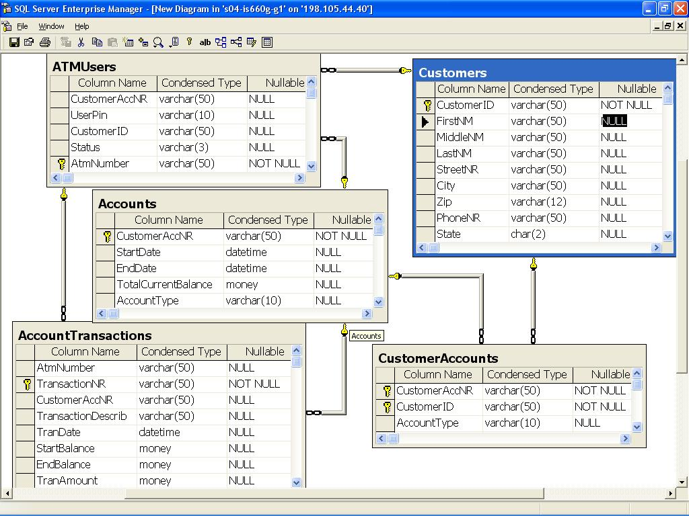

Use Case Diagram
Provided by Lisa Lau

Data Flow Diagram – Top Process
Provided by Andrew Newsome

Data Flow Diagram – Detail
Provided by Andrew Newsome

References

[1] Stephen Northcutt, Lenny Zeltser, Scott Winters, Karen Kent Frederick, Ronald W. Ritchey, “Network Perimeter Security”, 2003, Published by New Riders Publishing

[2] Nortel Networks, “IPsec and SSL: Complementary solutions”, White Paper

[3] Luis Felipe Cabrera, George Copeland, Bill Cox, Max Feingold, Tom Freund, Jim Johnson, Chris Kaler, Johannes Klein, David Langworthy, Anthony Nadalin, Ian Robinson, Tony Storey, Satish Thatte, “Web Service Atomic Transaction”, September 2003, Bea Systems, IBM and Microsoft

[4] Thomas Mikalsen, Stefan Tai, Isabelle Rouvellou, “Transactional Attitudes: Reliable Composition of Autonomous Web Services”, IBM T.J.Watson Research Center

[5] Brunner, et al, “Java Web Services”, 2002, Published by SAMS Publishing

[6] Luis Felipe Cabrera, George Copeland, Bill Cox, Tom Freund, Johannes Klein, Tony Storey, Satish Thatte, “Specification: Web Services Transaction (WS-Transaction)”, August 2002, Bea Systems, IBM and Microsoft

