# System Sequence Diagram Example

# Use case: Submit loan request

1. An applicant completes and submits a loan application to the bank via the Internet.
2. The system validates the information on the loan application, checking that it is correct and as complete as possible.
3. The system forwards a loan request to an external credit bureau for a credit report on the applicant.
4. The system calculates the applicant's credit score based on the returned credit report.

# SSD Solution

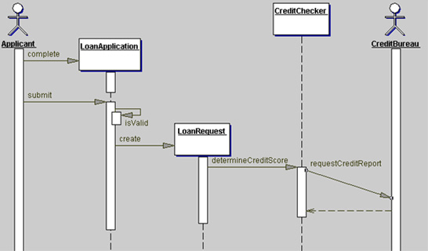

# Conceptual Class Diagram Exercise

Derive a conceptual class diagram from the use case description given below.

## Sample Use Case: Buy Ticket

A customer arrives at a ticket counter and wants to buy a ticket for a particular journey. The employee of the airline asks the customer for his wishes concerning

* the destination airport,
* the airport to start from,
* the date and time of departure,
* the class in which he wants to travel.

The employee enters these wishes into the flight information system which (hopefully) returns data about one or more possible flights matching the query. Each flight ist described by

* its number,
* date of departure,
* exact time of departure,
* time of arrival,
* price.

The customer chooses one of the possible connections found by the system and reserves this flight by getting a ticket for it. The ticket contains some further information such as the date of issue and whether the ticket is paid already or has to be paid at check-in time.

After the customer has received one or more tickets, he has to pay for them. Our sample airline supports two different methods of payment - pay by credit card or by debit card. If you pay by credit card, the airline registers the number of the credit card and its expiration date. For payment by debit card the bank code and the number of your bank account are read from the card for an electronic debit note. Independent of the payment method the customer chooses, the airline always records the amount of money being paid, the date of the payment and the signature of the customer.

# Conceptual Class Diagram Exercise Solution

