Frog Dissection

Introduction:
- What do the internal structures of the frog look like?
- How do amphibian organs compare to human organs?
- This activity will give you practice and some knowledge before we begin the real dissection experience.

Description:
- Explore the web site
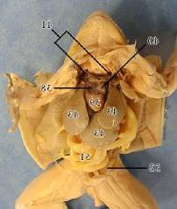
Virtual Frog Dissection

- Working in small groups of three or four, locate the body parts and organs listed on the lab sheet.
- Manipulate the virtual frog via commands in the program.
- Discuss and share their computer experiences.
Procedure:
- All work will be done in small cooperative groups (2-3 students).
- Each group will be assigned to one computer and given lab sheets.
- Open up the website link. Locate each organ listed on the frog diagram on the computer screen.
- "Click" on the organ. Copy the organ function listed at the top of window.
- "Click" on the green organ link at the top of the page. Sketch the picture given with plenty of detail.
- Remove the organ as directed. Continue with the next organ listed on the sheet.
- When you have completed the assignment place it in my inbox.
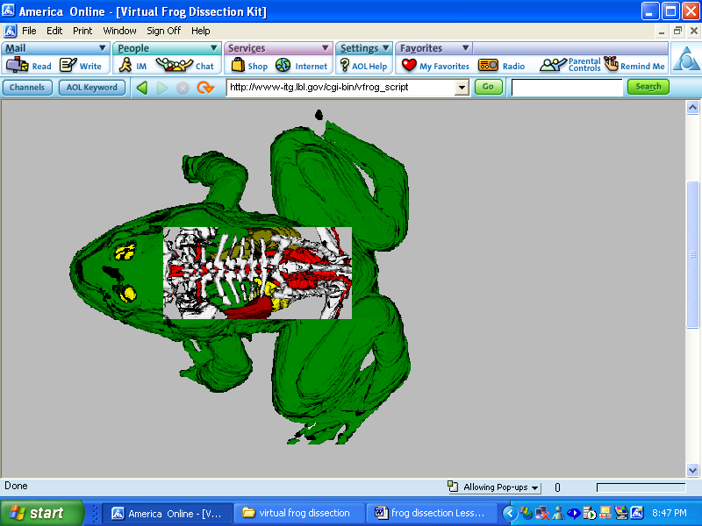

Evaluation: Group participation, discussion participation, and completion of lab sheet.
Conclusion: Important levels of organization for structure and function include cells, organs, tissues, organ systems, whole organisms, and ecosystems.
