Ajax

Ajax stands for Asynchronous JavaScript and XML. It was coined by Jesse James Garrett in 2005. It is used to update a part of a web page without having to replace the entire page. If the page has a lot of content with only a small amount needing to be changed, this saves a lot of time and band width. So it has become quite popular.
It is relatively easy to use Ajax with Rails. Most of the tricky things are hidden from the developer. The main thing needed is to add “:remote => true” to the update command. This tells the controller to do the update without sending a new web page, which is the usual response.
A simple example can be used to update the current time. Suppose we add the time to our index page.
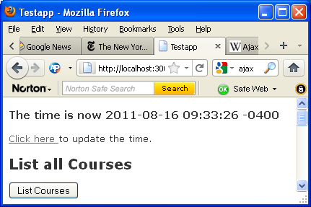
It is easy to add the time to the web page. Change the index method in the controller to
def index
@time = Time.now.to_s
end

And add to the top of the index web page the following:
<h3>The time is now <%= @time %></h3>

This provides the current time, but to update it, you have to reload the entire page. Note that to_s changes the internal representation of the time to a string.

In order to change the time without reloading the entire page, we can add the following code to the index page:

<div id="time_div">
<%= link_to "Click here ",
:url =>{ :action => :update_time },
:remote => true
%>
to update the time.
</div>

And this code to the controller:

def update_time
render(:update) do |page|
page[time_div].replace_html @time
end
end

When the user clicks on the link, “Click here”, a message is sent to the controller to execute update_time with the command
:url => {:action => :update_time}.
Because this is followed by
:remote => true
the action will be handled by the server without reloading the whole page. Also the method on the server, update_time, calls for the page to be rendered. This also says to replace only the indicated part, not the entire page.

Ajax is useful when you have a lot of things on your web page and do not want to have to reload the whole page each time there is a change. You should try it in some of your applications.

Jesse James Garrett, Ajax: A New Approach to Web Applications, 2005.

