The Organization of a Rails Application

Using Windows Explorer, we can see the layout of the folders created by the scaffold command.

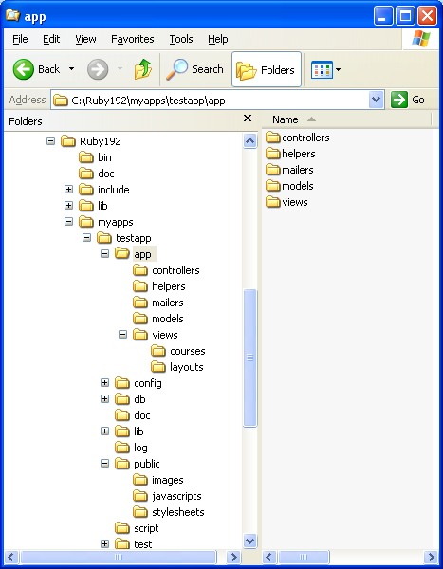

In the app folder you can see a number of subfolders, including models, views and controllers. These divide the application’s code into the sections described in the model/view/controller paradigm now frequently used by developers. The model handles the database, the view contains files to display web pages, and the controller manages the application.

Other important folders are the db folder and the public folder. The db folder contains the database, development.sqlite3 and a subfolder containing migration files. These are files that modify the database. We used one to create the courses table.

The public folder has subfolders for images, javascripts and stylesheets. If you place image files in the images folder, any reference to an image on a web page will look there to find them, similarly for JavaScript and cascading style sheets.

It is now recommended that all styles for an application be included in style sheets. HTML5 is doing away with all style tags except the tag, <style>, itself. All others should be used only in a style sheet, and the <style> tag should only be used for fast prototyping.

A style sheet you might want to add to your application creates gridlines for the table. It is contained in the file, schedule.css. Make sure that it is saved as a .css file and not a plain text file.

/* Global styles */

/* Styles for schedule/index */

table{
border: 1;
border-style: solid;
border-width: thin;
cellpadding: 10;
}

td {
border-style: solid;
border-width: thin;
padding-right: 0.5cm;
}

If you place this file in the public/stylesheets folder, Rails will include it when you open your application in a browser. This is because in the layouts subfolder there is a file, application.html.erb, that contains some of the standard lines required by every web page. It has lines for the header of a page and also the footer. One of the header lines tells the application to load all style sheets in the public/stylesheets folder.

<!DOCTYPE html>
<html>
<head>
<title>Testapp</title>
<%= stylesheet_link_tag :all %>
<%= javascript_include_tag :defaults %>
<%= csrf_meta_tag %>
</head>
<body>

<%= yield %>

</body>
</html>

Following the head and body tags, is a line, <%= yield %>, that says to insert the code from the web page that has been called.

Adding the schedule style sheet changes the appearance of the page as shown below. You might want to add colors and other modifications to the style sheet as well. You might also want to look at the page source to see how the page gets translated into standard HTML.

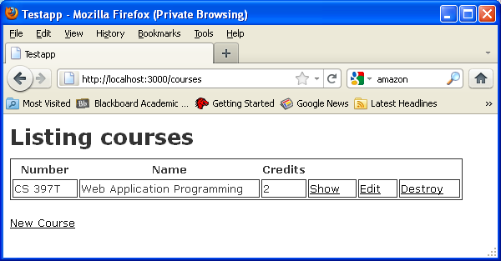

Refer to the document, Cascading Style Sheets, for more information.

